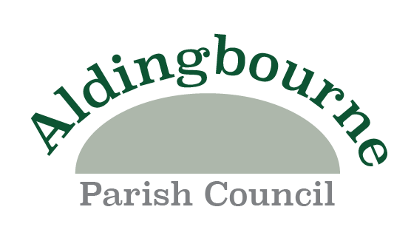

GENERAL POWER OF COMPETENCE

- BACKGROUND
1.1 Parish (and latterly town) councils are corporate bodies that have accumulated powers through legislation since 1894. Their powers were constrained to specific and appropriate legislation. This means that before undertaking anything, members must be satisfied that a town and parish council has the power (under a specified statute) to undertake that activity.
1.2 Town and parish councils have many specific powers (e.g., the provision of open spaces and recreational facilities) in addition to Section 137 of the Local Government Act 1972, permitting the expenditure up to certain limits for “purposes not otherwise authorised”. Typically, the expenditure on grants and sponsorship is covered by Section 137 of the Local Government Act, 1972.
1.3 Despite the wide range of powers town and parish councils are always at risk of being challenged, especially if they undertake an unusual activity. For example, a recent court ruling pronounced that pre-meeting prayers by a town council was unlawful.
1.4 In consequence, the Government included a “general power of competence” in the Localism Act 2011(Part 1, Chapter 1, SI 1-8). It was brought into force by SI 965. The Parish Councils (General Power of Competence) (Prescribed Conditions) Order 2012 in April 2012.

- LEGISLATIVE BACKGROUND:
2.1 The intention of the legislation is that eligible local authorities will no longer have to identify specific powers to undertake an activity. As a result, the risk of legal challenge will be reduced. It is stated in the above Statutory Instrument that.
“The Government’s intention in providing eligible parish councils with the general power of competency is to better enable them to take on their enhanced role and allow them to do things they have previously been unable to do under existing powers”.
2.2 Under the legislation, eligible councils have “the power to do anything that individuals generally may do” as long as they do not break other laws.
It is intended to the power of first not last resort. The eligible council has to ask itself if an individual is allowed to do it. If the answer is “yes” than an eligible council is normally permitted to act in the same way.

- TYPES OF ACTIVITIES
3.1 Although the Government has given scant guidance on the operation of the power, so new activities covered by the legislation include:
- Running a community shop or post office
- Lend or invest money.
  - Establish a company or co-operative society to trade and engage in commercial activity.
- Establish a company to provide services such as local transport.
- Providing grants to individuals
3.2 The power is not restricted to use within the parish. An eligible town/parish council can use it anywhere.

- RESTRICTIONS AND RISKS

4.1 The only real limitation is that the General Power of Competence cannot be used to circumvent an existing restriction in an existing specific power. The General Power of Competence is a power it cannot be used to raise the percept.
4.2 Existing duties remain in place, such as having regard to the likely effect on crime/disorder and biodiversity. There are also many existing procedural and financial duties that remain in place for the regulation of governance e.g., no delegation to a single councillor. Furthermore, councils must comply with relevant existing legislation e.g., employment law, health and safety, equality legislation and duties relating to data protection and freedom of information.
4.3 If another council has a statutory duty to provide a service e.g., education, social service, highways footpaths rights of way. It remains their duty to provide it. Nonetheless, eligible town and parish councils may assist. The eligible town/parish council would need to ask itself whether an individual private company or community trust could help. If the answer is “yes” the town/parish council can assist.
4.4 Whilst councils are encouraged to be innovative, they should be aware of the risks of:
- Being challenged
- Their trading activities damaging other local enterprises.
  - Damage to the Council’s reputation and public money if a project or investment goes wrong.

- LOCAL GOVERNMENT ACT 1972 s137
5.1 Expenditure under the Local Government Act 1972 is limited and must be budgeted for separately. Expenditure is restricted in that it cannot be used to give money to individuals and the amounts must be commensurate with the benefit. Section 137 is a power of last resort.
5.2 A council that is eligible to use the general power of competence can no longer use Section 137 as a power for taking action for the benefit of the area. However, Section 137 which permits the council to contribute to UK Charities public sector funds and public appeals remains in place.

- ELIGIBILITY
6.1 The THREE conditions for eligibility are set out in the Statutory Instrument (paragraph 1.4 above) as follows:
- RESOLUTION: The Council must resolve at a meeting that it meets the criteria for eligibility relating to the electoral mandate and relevant training of the clerk
- ELECTORAL MANDATE: at the time the resolution is passed, at least two thirds of the council must hold office as a result of being declared elected (i.e., not co-opted)
- QUALIFIED CLERK: At the time that the resolution is passed, the Clerk must hold a recognised professional qualification e.g., Certificate in Local Council Administration.
6.2 Having decided at Full Council meeting that it meets the criteria for eligibility at that particular time a resolution to this effect must be written in the minutes. The Council is then required to revisit that decision and make a new resolution at every “relevant” annual meeting of the council to confirm that it still meets the criteria (if it does). A relevant annual meeting is the annual meeting of the council after the next ordinary election has taken place.
6.3 In consequence eligibility remains in place until the “relevant” annual meeting even if the conditions of the eligibility criteria have changed. If the council loses it qualified Clerk or has insufficient elected councillors it must record its ineligibility at the next “relevant” meeting.
6.4 The is no requirement for members to be trained in the General Power of Competence

ALDINGBOURNE PARISH COUNCIL SATISFIES ALL THE CONDITIONS AS:

- It has 8 out of 10 councillors elected.
- The Clerk holds the Certificate in Local Council Administration (CiLCA) – November 2022.
For information, the resolution to adopt the General Power of Competence was passed at the AGM Full Council Meeting 16.05.23.

