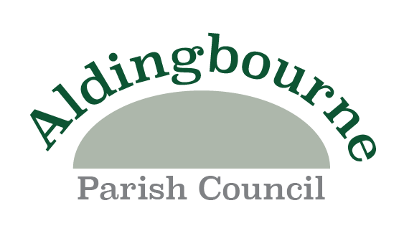

CHAIRMANS ANNUAL PARISH ASSEMBLY REPORT
Thank you for being with us tonight and I trust that you will be suitably entertained.
I would like to extend a welcome to all our residents attending tonight.
I would also like to thank my fellow Councilors for entrusting me with the Chairmanship for a further year and as I said at last years Parish Assembly, I expect it will be just as challenging.
The Planning Committee considers all applications which are relevant to the Parish for consultation. This Committee is not a platform for making a decision on an application, it is an opportunity to voice our concerns as well as yours.
I will start with what has probably been the most dominant part of Council business as it was last year and that has been trying its best to fend off unwanted over-development of the parish and it doesn’t look as if that will change, but we will continue to act in the interests of the Community, on planning matters.
One positive to come from some of the developments is that the CLT will be acquiring housing next month on what is known as the Wings Nursery site to house people residing in the Parish or have specific connections and they will become available within the next month. The two new bus stops will come under the ownership of the Council when the necessary paperwork is completed.
Also, In July the site opposite will commence and there will be further properties being made available to the CLT. The Council will take ownership of some new Allotment plots as well once the legal paperwork is completed. You can glean more information on CLT from the Councils website where there is a link.
Development in Aldingbourne and applications to develop do not seem to have reached a peak and the reality is that the Parish will have to absorb more housing, but we will still keep on fighting to try and make a difference. The infrastructure is not keeping pace with developments and that is something that we all need to stand up for and residents can help us with that aspect.
The Council has an adopted Neighbourhood Plan and will be reviewing and updating that Plan shortly it is hoped that proposed alterations to the NPFF from government, which is also being updated, will contain favourable policies that will give Parish Councils a more defined and better voice on applications.

The Finance Committee has policies in place for managing your money and there is a clear picture of how we spend that money through a planned Budget and Business Plan. And all those financial matters are available on our website. In fact, all the minutes and actions of the Council are accessible on that website.
The Full Council manages all business relating to the parish and has been actively engaged in working with the Aldingbourne Community Sports Centre in looking at ways to make it better for the Community via a Development Scheme which is proving more challenging than first envisaged but is still very much a work in progress. The working party is managed by the four principal officers of both organisations and the aim is to develop the whole of the complex here and its clubs and user groups for the betterment of the Community. It is a long-term project which will not be achieved for a number of years.
You will hopefully have seen the large sculpture by the side of this building which was paid for by monies contributed from developments in the Parish. The design was carried out by an Artist who enlisted the help of local schools and if you look closely, you can see the artwork from the children worked into the sculpture. Developers have to contribute to a range of services within the district and further monies will be become available and suggestions would be welcome on how to use that money.
We work closely with our District and County Councillors and with our local PCSO. They update us on current issues and take our and the residents’ comments back to the respective people to put our views forward.
Other parts of council business are managed by working parties, which are formed when required and one such party is the Street Scene Working Party and that is active in matters of the public realm and outside spaces, which Cllr Harbord will tell you more about shortly.
The Council has formed a working party that is looking into IT/MEDIA and communications to put a strategy together that will improve how we engage and advise the Community of what is happening.
The Council administers the Westergate Recreation Ground Fund, a Charity set up to manage the upkeep of the Playing Fields and open spaces throughout the Parish.
The Council has recently achieved the status of the General Power of Competence, which enhances our ability to carry out more diverse projects and activities. A document will be on our website soon which will explain more of why it is an important achievement to obtain.
A new CCTV system has been put in place on the complex which will give better security.
A new pedestrian crossing will be constructed by WSCC, which the Parish Council has supported, adjacent to the Six Villages Academy to aid in the crossing of a road that is getting ever busier.
Let me conclude by saying that all council meetings are open to the public, that an item on agendas allow your voices to be heard on anything you have concerns over, suggestions or requests for improving the community and dare I say thanks when we do something positive.

